**Test Case 0040 (part 1)**

**System:** VirtuCardsClient & VirtuCardsHost

**Description:** test that ensures the different reactions are sent and displayed correctly.

**Severity:** 3

**Instructions**

1. Start VirtuCardClient application
2. Click the button labeled “Sign In”
3. Enter “virtucards01@gmail.com” into the text input labeled “Enter email…”
4. Enter “Testing1” into the text input labeled “Enter password…”
5. Press the button labeled “Login”
6. A window should appear saying “Login Success”
7. Press the OK button that appears on that window
8. Start VirtuCardHost application
9. Repeat steps 2-7 but on the VirtuCardHost application
10. The checkbox “Allow Host to Join” should be checked on the host
11. Press the Create Game button
12. In the VirtuCardClient application enter the 6-character room code found on the host’s screen into the field labeled “Enter Code…”
13. Press the Join Game button on the client
14. After the name TestCase0001 appears in the player list on the host side, press the Start Game button
15. On the client-side, hide chat
16. Press the Purdue or IU logo

**Expected Result:** The picture of the BoilerMaker Special with the “Boiler Up” sign above will come closer to the screen with the AAMB playing the “Quickie” of Hail Purdue in the background or picture of the Purdue Pete above the IU mascot with the “Hammer Down” sign above will come closer to the screen with the AAMB playing the end of the Fighting Varsity playing in the background.

**Test Case 0040 (part 2 )**

**System:** VirtuCardsClient & VirtuCardsHost

**Description:** test that ensures the different reactions are sent and displayed correctly.

**Severity:** 3

**Instructions**

1. Start VirtuCardClient application
2. Click the button labeled “Sign In”
3. Enter “virtucards01@gmail.com” into the text input labeled “Enter email…”
4. Enter “Testing1” into the text input labeled “Enter password…”
5. Press the button labeled “Login”
6. A window should appear saying “Login Success”
7. Press the OK button that appears on that window
8. Repeat steps 2-7 with [micro@soft.com](mailto:micro@soft.com) and Password!123
9. Start VirtuCardHost application
10. Repeat steps 2-7 but on the VirtuCardHost application
11. The checkbox “Allow Host to Join” should be checked on the host
12. Press the Create Game button
13. In the VirtuCardClient application enter the 6-character room code found on the host’s screen into the field labeled “Enter Code…”
14. Press the Join Game button on the client
15. After the name TestCase0001 appears in the player list on the host side, press the Start Game button
16. On the client-side, hide chat
17. Press the Purdue or IU logo

**Expected Result:** If one user clicks on the button, the animation will show up both VirtuCards clients with both playing the music and the cooldown afterwards.

**Test Case 0040 (part 3)**

**System:** VirtuCardsClient & VirtuCardsHost

**Description:** test that ensures the different reactions are sent and displayed correctly.

**Severity:** 3

**Instructions**

1. Start VirtuCardClient application
2. Click the button labeled “Sign In”
3. Enter “virtucards01@gmail.com” into the text input labeled “Enter email…”
4. Enter “Testing1” into the text input labeled “Enter password…”
5. Press the button labeled “Login”
6. A window should appear saying “Login Success”
7. Press the OK button that appears on that window
8. Start VirtuCardHost application
9. Repeat steps 2-7 but on the VirtuCardHost application
10. The checkbox “Allow Host to Join” should be checked on the host
11. Press the Create Game button
12. In the VirtuCardClient application enter the 6-character room code found on the host’s screen into the field labeled “Enter Code…”
13. Press the Join Game button on the client
14. After the name TestCase0001 appears in the player list on the host side, press the Start Game button
15. On the client-side, hide chat
16. Press the IU or Purdue logo

**Expected Result:** After pressing one of the buttons, the animation will show up. After that, there will be a 60-second cooldown before any player in the game can press again.

**Test Case 0040 (part 4)**

**System:** VirtuCardsClient & VirtuCardsHost

**Description:** test that ensures the different reactions are sent and displayed correctly.

**Severity:** 3

**Instructions**

1. Start VirtuCardClient application
2. Click the button labeled “Sign In”
3. Enter “virtucards01@gmail.com” into the text input labeled “Enter email…”
4. Enter “Testing1” into the text input labeled “Enter password…”
5. Press the button labeled “Login”
6. A window should appear saying “Login Success”
7. Press the OK button that appears on that window
8. Start VirtuCardHost application
9. Repeat steps 2-7 but on the VirtuCardHost application
10. The checkbox “Allow Host to Join” should be checked on the host
11. Press the Create Game button
12. In the VirtuCardClient application enter the 6-character room code found on the host’s screen into the field labeled “Enter Code…”
13. Press the Join Game button on the client
14. After the name TestCase0001 appears in the player list on the host side, press the Start Game button
15. On the client-side, hide chat
16. Press the IU or Purdue logo
17. Repeat previous step

**Expected Result:** When someone presses the button, everybody will be in a cooldown, but if a user tries to click on the button again, the sign that reminds them of cooldown will show up and fade in a second.

Part 1 & part 2

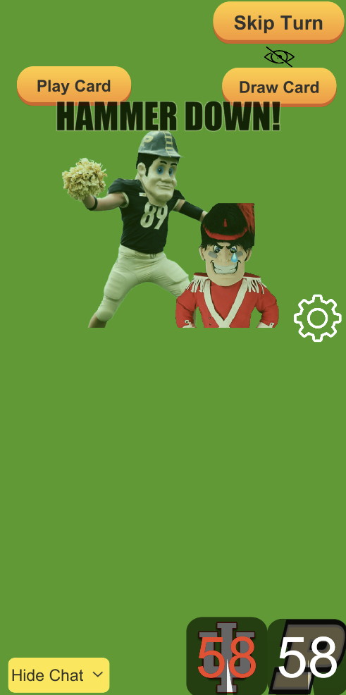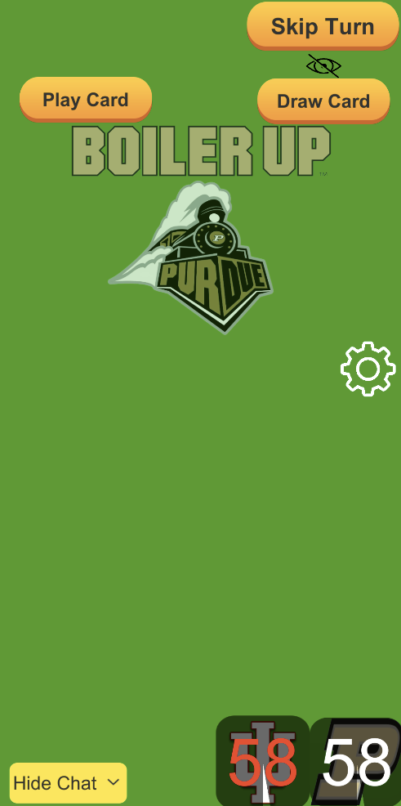

If one user presses one of the buttons, one of these animations will show up on everybody’s client screen. IU logo on the left and Purdue logo on the right.

Part 3 & part 4



After one of the users has pressed the IU or Purdue logo, they will be given a cooldown to ensure that players do not abuse this power. When a player tries to click on the button during a cooldown, they will be given a quick sign on the right picture. After the time has set, they will have the power to do an animation again.